Time | Monday | Tuesday | Wednesday | Thursday | Friday
08 – 10
10 – 12 | Languages in Europe  (Neis)  OSL 239.1  Start: 16.09. |  | Science as Culture  (Junk/Frercks)  OSL 655  Start: 18.09.
12 – 14 | European Economy  (Özek)  OSL 239.1  Start: 16.09. |  | Europe as Educ. Space  (Wigger)  HEL 066  Start: 18.09.
14 – 16 | Migration and Mobility in Europe  (Carlson)  OSL 248  Start: 16.09.  Every 14 days | Sustainability and Pol. Ecology  (Sommer)  HEL 067  Start: 17.09.
16 – 18
18 - 20
HeSe 2019/20
5th semester
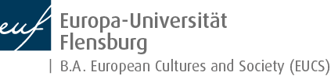

Please don’t forget to register in the Autonomous Project of your choice + Reflection on projects in Studiport. More information on the Autonomous Project can be found here: https://www.uni-flensburg.de/en/eucs/information-for-students/enrolled-students/

