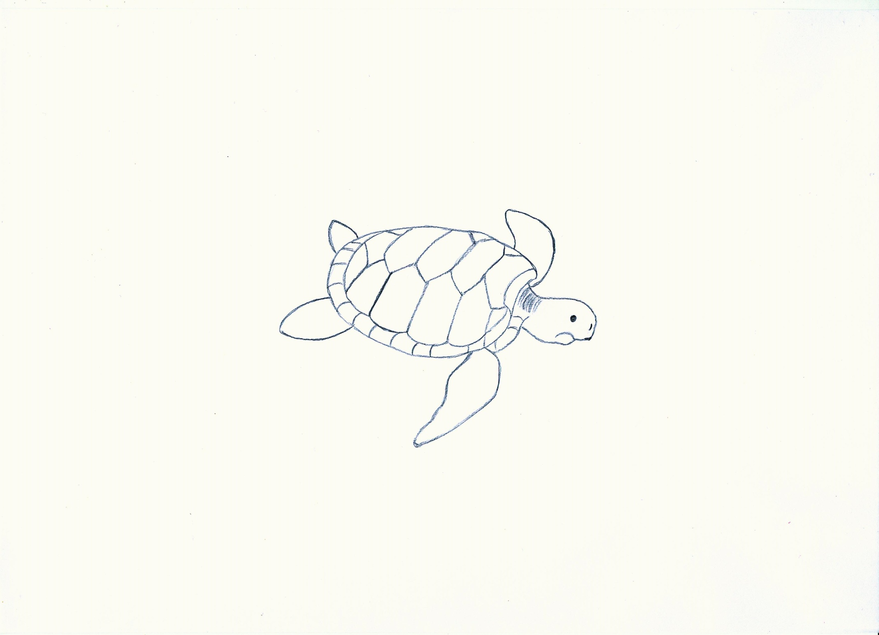

* humans
* carnivores
* pollution of the sea (plastic bags)
* fishermen
* big fishing nets
* hotels

WS 3