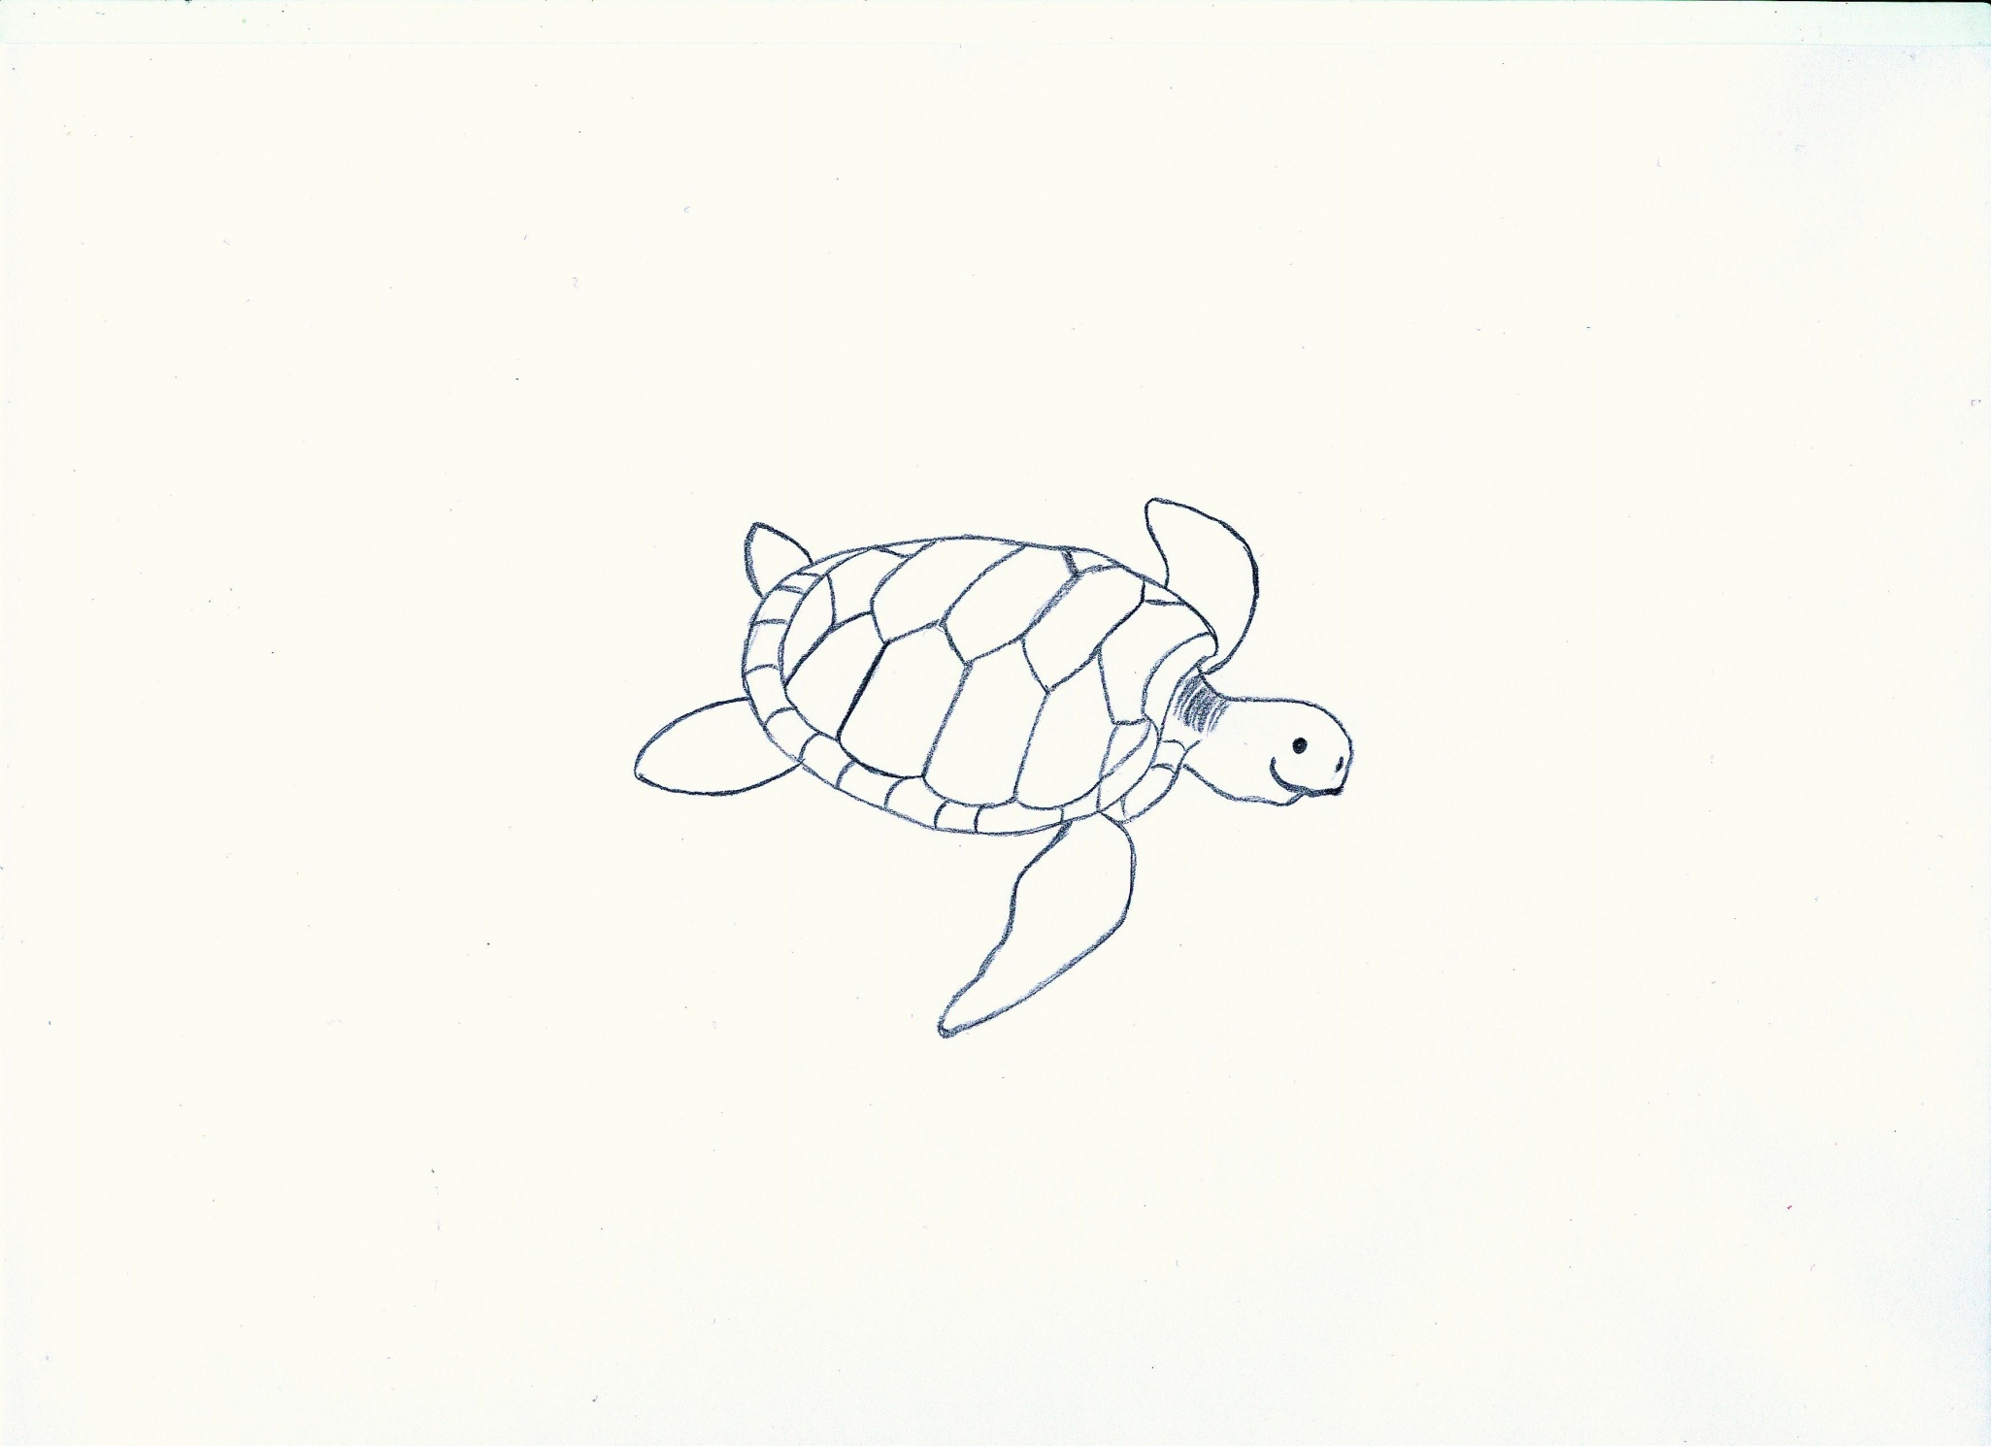

* ocean
* beach
* heat of the sun
* calamari
* crawfishes
* jellyfishes
* shellfish
* sea urchins
* sea cucumbers
* sea weeds
* algae

1._fins__________________________________ 2._domed carapace_____________________________

3._mouth without teeth______________________ 4._flat carapace_______________________________

WS 2

**4**

domed carapace/ fins/ flat carapace/ mouth without teeth

**1**

**1**

**1**

**3**

**2**

**1**