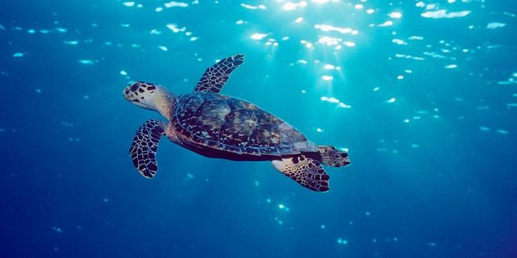

There are seven different species of sea turtles, which are all different in size and weight. Apart from that they are similar. They spend their whole life in the ocean and swim miles and miles. Every third year the females come back to the beach where they were born themselves to lay their eggs in the sand.

WS 1

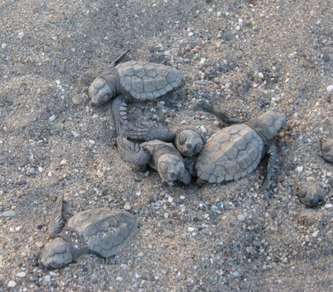

Over two months the sun hatches the eggs with its heat. One night the sea turtles emerge and go straight to the ocean. This walk is very dangerous for young sea turtles because they can only move very slowly. That is why they are easy prey for humans and carnivores.

In the ocean there are serious dangers for sea turtles. One of these is the pollution of the sea. For example, turtles eat plastic bags floating in the sea because they look like jellyfish. Many sea turtles die because of this.

Sea turtles eat jellyfishes, calamari, crawfishes, shellfish, sea urchins and sea cucumbers. But there are also sea turtles which only eat different sea weeds and algae. Sea turtles gobble their food without chewing because they do not have teeth.

The fishermen are the second major danger. They want to catch as many fishes as they can with their big fishing nets. The sea turtles blunder into these nets and cannot disengage themselves.

Other humans are the third major danger. Some of them want to sell turtle meat and carapace. Others build hotels at the beaches, so there are lots of people at the beach, which prevents the female turtles from laying their eggs in the sand.

