

D6.1 – Common Research Strategy

Project Acronym: EMERGE Project ID: 101177486
Programme: ERASMUS2027 Deliverable Number: D14 (D6.1)
Deliverable Lead: UDC Submission Date: 30 Jun 2026 (M18)



Document Title | D6.1 – Common Research Strategy – Deliverable Report
Type of Submission | ☒ Deliverable ☐ Milestone ☐ Other Output
Work Package Title | Knowledge co-creation to address the challenges  of our territories
WP Number | WP6 |  |  |  | Del. Number | D14
WP Lead | UDC |  |  |  | WP Co Lead | UMB
Lead Author Name | Pablo Rodríguez-Vellando Fernández-Carvajal
Contributors | WP6 Partners
Submission Lead | UDC |  |  |  | Submission Due | 30/06/2026 | (M18)
Change Control

Document Version | 0.4 | Status | ☒ Draft ☐ Final for Approval ☐ Final for Upload
Change: | Update for final upload; Minor edits
Previous Versions | - Template, style and content revision  - Content additions  - Initial Template Version
Folder Location | EMERGE Alliance Site > General > EMERGE Deliverables > WP6 Deliverables
Quality Checks

Review required by | ☐ Alliance Management Team ☐ Project Management Team  ☒ Quality Assurance Team ☒ Steering Committee
Action for Recipients
Reviewed By QAT | 29/06/2026
Reviewed By AMT/PMT/Coord | 29/06/2026
Approval By SC | 03/06/2026
Submission Information

Funding & Tenders Portal Status | ☐ Version for upload ☒ Pending upload  ☐ No upload needed ☐ Update requested
For Upload Version | v1.0 |  |  | Upload Date |  | 30/06/2026 | (M18)
Supporting Information


Co-funded by the European Union. Views and opinions expressed are however those of the author(s) only and do not necessarily reflect those of the European Union or EACEA. Neither the European Union nor the granting authority can be held responsible for them. ©2026 EMERGE European University Alliance

Executive Summary - Internal
This document constitutes Deliverable D6.1 – Common Research Strategy, prepared under Work Package 6 (Knowledge Co-creation) and submitted in fulfilment of the corresponding commitment under the EMERGE Grant Agreement. The deliverable provides the common research strategy agreed by the Alliance partners and establishes a shared framework to strengthen collaborative, participatory and challenge-driven research across the consortium.
Building on the work completed under Milestone MS22 – Common Research Strategy Draft, the document consolidates the contributions of all partner institutions and reflects consultations with the Strategic Planning Unit, research vice-rectors and other relevant EMERGE governance bodies. Following internal review, it was approved by the Steering Committee as the final common research strategy of the Alliance.
In line with the objectives set out in the Grant Agreement, the strategy defines common research priorities and guiding principles while remaining complementary to the individual research agendas of the partner universities. It is intended to support long-term cooperation, reinforce research capacity and contribute to the development of the EMERGE Research Campus and the Alliance’s broader mission of empowering the margins through knowledge co-creation and societal engagement.
The following internal sections document the project-specific context and demonstrate compliance with the relevant Grant Agreement commitments, while the public section presents the strategy in an accessible format for external audiences.

Project Report
This section contains internal project references that are not relevant to a wider public audience and have therefore been omitted from the public version.
Actions
In order to promote and support engaged research within our institutions, the following will be available to the EMERGE research community:
- A digital catalogue of current resources, infrastructures, research groups, innovation and transfer capacities from all the members (T6.1.2), including new tools for community-engaged participatory, collaborative and challenge-driven research (T6.1.3)
- Training seminars on community-engaged participatory research tools and methods (T6.3.1)
- Training programmes on transversal skills development and scientific communication for PhDs and Post-docs (T6.3.2)
- Research fellowships for senior researchers to engage in international collaborations, possibly involving new communities in participatory research formats (T6.2.1)
- Scientific forums to engage researchers with stakeholders and develop collaborative research efforts (T6.2.3)
- A joint call for research proposals funded by all the members (T6.2.4)
In addition to these actions:
- Initiatives will be undertaken to support early-stage researchers through the interconnection of doctoral schools across the Alliance, with a view to establishing a joint doctoral school (T6.3.3)
- Early-stage researchers will present their work, meet potential employers, upgrade their soft skills, and receive professional counselling at Career Days (T6.2.2)
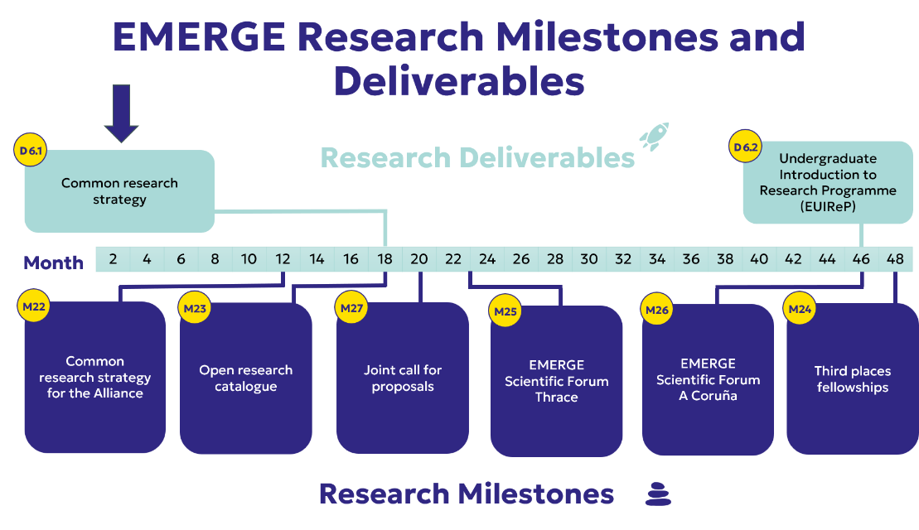
- Undergraduate students will have access to a dedicated research programme, which will bring together students from various fields to collaborate on problem-solving activities and engage in project-based learning through community participation (T6.3.4)

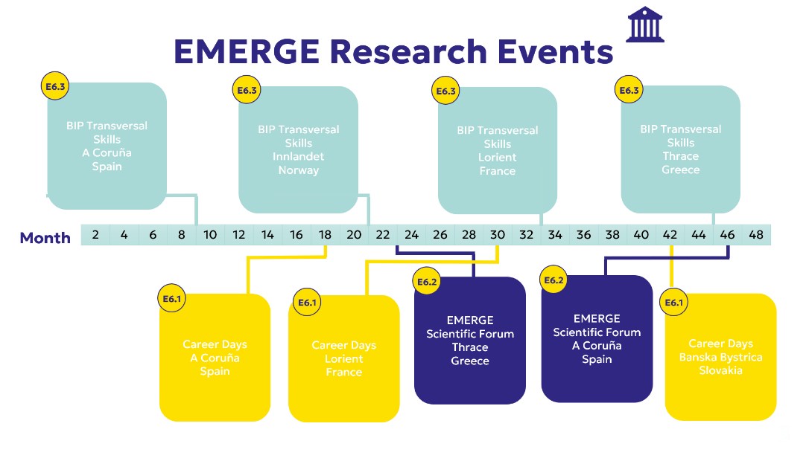
Means and tools
Comprehensive communication of current research resources, strategy goals and needs for complementary resources.
As part of task T.6.1, a comprehensive inventory of current research practices and resources has been compiled, and areas for improvement and opportunities for collaboration have been identified. Special attention will be given to including the stakeholder network built by WP2 and WP6. This interface facility will be provided in connection with other Alliance communication tools, particularly the tasks assigned to WP1 (Governance and Project Management), WP2 (Community Engagement and Services), WP3 (Educational Programmes) and WP9 (Communication, Dissemination and Outreach).
Further actions
Once tasks within T6.1 have been completed and there is an alliance-wide and institutional awareness of all current resources and objectives. A number of additional research actions—not originally included in the proposal—have been identified as strategic and may prove key to Alliance research beyond the Project boundaries.
1. Constitution and consolidation of EMERGE Research Groups.
These units would be extremely well-positioned to take part not only in EMERGE tasks included in T6.2 and T6.3, but also for further prospective activities. Involving stakeholders in the ERGs is highly desirable, and guidance will be sought from WP2 for this purpose.
2. Catalogue for shared research infrastructures.
To facilitate access to research infrastructures across the Alliance and increase the impact and efficiency of research endeavours, a specific mapping of shared research infrastructures, extracted from T6.2, is required.
3. Eventual strengthening of research human resources interactions among university partners.
Just as physical infrastructures are known and shared, research human resources should also be listed and shared among partners. This should be considered in connection with fellowships (T6.2.1) and other T6.2 and T6.3 activities that promote the mutual knowledge of material resources and human teams.
4. Additional quest for funding from public/private institutions beyond the EMERGE Project requirements.
Several of the activities in T6.3 have already focused on training researchers to enhance knowledge of the European Commission's Horizon Europe programme guidelines and its funding opportunities. Several of these are required under the EMERGE Grant Agreement, particularly those included in T6.3.3 Doctoral Networks. However, the Alliance also seeks to go beyond the minimum requirements set out in the agreement. Applications have already been prepared, submitted and listed in EMERGE internal documentation, and further proposals will follow that adjust to the capacities and scope of the Alliance.
Additional funding possibilities will be sought that make use of the stakeholder network developed both by WP2 and WP6 to strengthen collaboration with regional community-based ecosystems and industries to drive innovation and address societal challenges. This would result in additional funding for the Alliance and valuable knowledge transfer for stakeholders.
6. EMERGE Research Community (EMERGE RechComm).
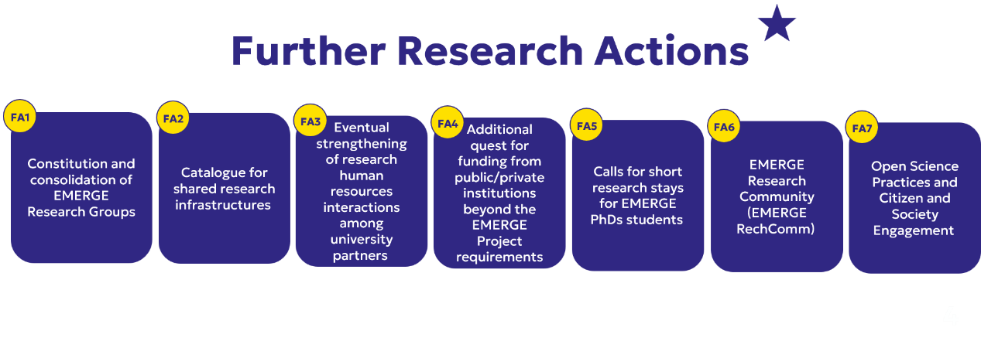
Within EMERGE RechComm, the EMERGE Research Community could also host the EMERGE Undergraduate Introduction to Research Programme (EUIReP, T6.3.4).

EMERGE D6.1 Submission Process & Internal Timeline
Indicative timeline | Stage owner | No. | Process step | Description | Responsible | Relevant Dates
~10 weeks before EC deadline  Initial drafting period | Deliverable Lead ownership | 1 | Deliverable Lead begins drafting using PM-provided template | Deliverable Lead uses the template as the master working document and begins drafting. | Deliverable Lead (Del Lead)
~10 weeks before EC deadline  Initial drafting period | Deliverable Lead ownership | 2 | Deliverable Lead coordinates partner input | Inputs are gathered from WP Lead, WP Co-Lead and relevant partners. The Del Lead owns coordination, version control and content consolidation. | Del Lead with WP Lead / Co-Lead and partners
~10 weeks before EC deadline  Initial PM check | Initial PM check | 3 | Initial informal check-in with PM | Early check on structure, scope, Grant Agreement alignment, evidence base, partner input gaps and overall timeline. | Project Manager (PM) | 19 Apr 2026
After initial PM check  If needed | Revision loop | 3a | If not on track: revise scope, structure or evidence base | Del Lead addresses issues identified during initial PM check and returns to the initial check step if necessary. | Deliverable Lead (Del Lead)
~5–6 weeks before EC deadline  Advanced draft stage | Advanced PM check | 4 | Advanced informal check-in with PM | Near-final PM check to ensure the draft is ready for formal internal review by Secretary General and QAT. | Project Manager (PM) | 20 May 2026
After advanced PM check  If needed | Revision loop | 4a | If not ready: complete missing sections / partner input | Del Lead completes missing sections, resolves open comments and confirms the document is ready for formal review. | Deliverable Lead (Del Lead)
~1 week before SC meeting  Normally before start-of-month SC | SecGen & QAT review | 5 | Send advanced draft to Secretary General and QAT | Advanced draft is sent at least one week before the relevant SC meeting. This is the formal internal quality and strategic review gate. | Deliverable Lead (Del Lead) | 27 May 2026
~1 week before SC meeting | SecGen & QAT review | 6 | QAT and Secretary General review | QAT reviews quality, completeness, GA alignment and evidence. Secretary General reviews strategic alignment and Alliance-level coherence. | QAT and Secretary General
Immediately after QAT / SecGen review | Deliverable Lead ownership | 7 | Deliverable Lead incorporates comments | Del Lead integrates review comments, resolves issues and prepares a version suitable for SC approval or SC noting. | Deliverable Lead (Del Lead)
Start of submission month  Typically 4–5 weeks before EC deadline | SC approval gate | 8 | Steering Committee approval for Public Deliverables | Public deliverables require SC approval. Sensitive deliverables receive QAT/SecGen validation and SC noting unless full SC approval is required. | Steering Committee (SC) | 03 Jun 2026
After SC meeting  If required | SC revision loop | 8a | If not approved: revise and resubmit as directed | Del Lead addresses SC comments and resubmits according to the agreed route. | Deliverable Lead (Del Lead)
After SC approval / noting | Finalisation | 9 | Final clean version prepared | Final version is cleaned, checked for formatting, metadata, title, dissemination status, funding statement and evidence/annexes. | Deliverable Lead (Del Lead)
~1 week before EC deadline  Final to PM | Final to PM | 10 | Final deliverable submitted to PM for upload | Del Lead submits the final approved clean version to the PM by the internal upload deadline. | Deliverable Lead (Del Lead) | 18 June 2026
After final to PM  Before EC deadline | Final compliance check | 11 | PM / Coordinator final compliance check | PM / Coordinator checks file, title, version, dissemination level, compliance, formatting and upload readiness. | Project Manager / Coordinator
On or before EC deadline  Portal submission | Portal submission | 12 | Coordinator uploads to EU Funding & Tenders Portal | Coordinator uploads the deliverable to the Portal Continuous Reporting tool and logs the submission. | Coordinator / UL | 30 June 2026
After upload | Close-out | 13 | Submission logged and confirmation circulated | PM records submission and confirms completion to Del Lead, WP Lead, WP Co-Lead, Secretary General and QAT as appropriate. | Project Manager (PM)

Colour Key and Role Clarifications
Colour | Meaning | Use in process
PM blue | PM set-up, initial PM check, and final PM / Coordinator compliance checks. | Applies to PM-owned checks and set-up stages.
Deliverable Lead orange | Stages owned by the Deliverable Lead, including drafting, partner input, formal circulation to SecGen/QAT, comment incorporation, and revision loops. | Applies wherever the Del Lead is responsible, including step 1.
Advanced PM purple | Near-final advanced draft check with PM before formal internal review. | Applies to the advanced PM check only.
SC red | Steering Committee approval gate for Public deliverables; SC noting / validation route for Sensitive deliverables unless full approval is required. | SC timing is start of submission month / around 4–5 weeks before the EC deadline.
Final green | Final approved clean version submitted by Deliverable Lead to PM for Portal upload. | Marks the internal final-submission deadline to PM.
Portal grey | External submission / close-out steps, including Coordinator upload to the EU Funding & Tenders Portal. | Applies to formal upload and post-upload confirmation.
Role clarifications
Role | Responsibility
Deliverable Lead / Del Lead | Owns the specific deliverable. Coordinates drafting, gathers partner input, manages revisions, prepares the final clean version and submits it to PM by the internal deadline.
WP Lead | Responsible for the overall WP and for ensuring the deliverable fits the WP objectives and Grant Agreement logic. Usually also the Del Lead, but not always.
WP Co-Lead | Supports WP delivery and may act as Deliverable Lead for specific deliverables. Known exceptions: D8.1 led by INN and D2.2 led by UL.
Project Manager / PM Team | Provides the template, date control, informal checks, final compliance checks, tracker updates and upload preparation.
Secretary General | Reviews for strategic alignment, Alliance-level coherence and governance consistency.
QAT | Reviews for quality, completeness, evidence and Grant Agreement alignment.
Steering Committee | Approves Public deliverables and notes/validates Sensitive deliverables unless full approval is required.
Coordinator / UL | Uploads final deliverables to the EU Funding & Tenders Portal.

Timing note: Exact dates may vary depending on meeting calendars, weekends, holidays and changes due to feedback.

Common Research Strategy for EMERGE Alliance Universities
June 2026
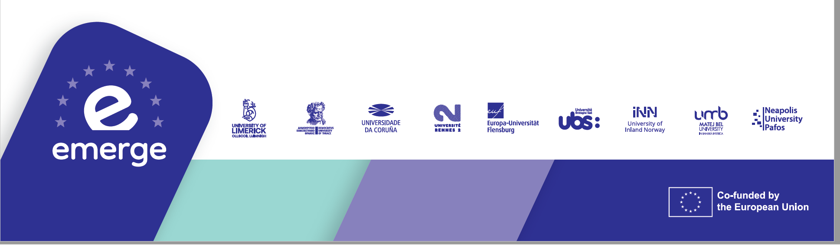

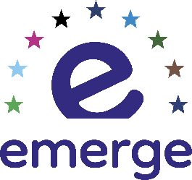
Empowering the Margins of Europe through Regional and Global Engagement Alliance

Contents
Executive Summary 3
1. Background 4
2. Thematic research clusters 6
3. Objectives 7
4. Actions 9
5. Means and tools 11
6. Further actions 13

Co-funded by the European Union. Views and opinions expressed are however those of the author(s) only and do not necessarily reflect those of the European Union or EACEA. Neither the European Union nor the granting authority can be held responsible for them. ©2026 EMERGE European University Alliance

Executive Summary
The EMERGE Common Research Strategy establishes a shared vision for research collaboration across the Alliance, bringing together the complementary strengths of its partner universities to address societal challenges through interdisciplinary, participatory and internationally connected research.
Rooted in the Alliance’s mission of empowering the margins of Europe, the strategy recognises that universities located in geographically and socially diverse regions can generate innovative solutions by working collaboratively with researchers, public authorities, industry, civil society and local communities. It promotes research that is not only conducted about communities, but also with and for them, ensuring that knowledge creation contributes directly to societal development.
To achieve this vision, the strategy identifies a set of common research priorities and establishes a shared framework for cooperation across the Alliance. It outlines key actions to strengthen research excellence and long-term collaboration, including:
- fostering interdisciplinary research around shared thematic priorities;
- supporting researcher development, mobility and capacity building;
- promoting community-engaged and challenge-driven research;
- encouraging open science, knowledge exchange and collaboration with external stakeholders;
- strengthening the EMERGE Research Campus as a shared environment for resources, expertise and collaborative initiatives; and
- creating opportunities for joint projects and international funding.
Together, these actions aim to reinforce research capacity across the Alliance, increase the visibility and impact of collaborative research, and establish lasting partnerships that extend beyond the lifetime of the current project. By providing a common strategic direction while respecting the individual strengths of each partner institution, the EMERGE Common Research Strategy contributes to the development of a more connected, inclusive and resilient European Research Area.

Background
At both national and international levels, the emergence of research programmes centred on public engagement and involvement, innovation missions and industrial competitiveness is reshaping a more inclusive research landscape. Within this changing and dynamic context, collaboration between researchers and a range of public research stakeholders –including civic and civil society organisations, state and semi-state agencies, industry partners, professionals, and members of the public– has increasingly shifted from the margins to the mainstream of research design and implementation.
The EMERGE research strategy is centred on multidisciplinary, interdisciplinary and transdisciplinary research, as well as on the international, challenge-driven and community-driven co-creation of knowledge. The process of co-creating knowledge focuses on facilitating methods, resources and shared ambition, with the aim of strengthening links between research, industry, government and civil society.
The entire process of community-engaged participatory research can be subsumed under the concept of engaged research.
Engaged research refers to a broad range of rigorous research approaches and methodologies that share a common interest in collaborative engagement with research stakeholders, which seek to improve, understand, or investigate an issue of public interest or concern.
Engaged participatory research implies collaborative actions with community as opposed to university actions for them.
The twin ambitions of EMERGE Research are, first, to strengthen the research community and its resources, with a focus on developing a robust research architecture and providing support for researchers within the consortium to better address the global and local challenges impacting our territories and communities; and second, to include representation and opportunities for the involvement of marginalized communities interested in and impacted by our research. This will be achieved through activities that promote co-design, collaboration, knowledge production and exchange, thereby creating a research and innovation environment that consciously engages society as a whole. We will work to promote best practice in engaged research, paying close attention not only to ‘traditional’ research ethics concerning GDPR compliance —namely data governance, informed consent, and safeguarding protocols for vulnerable groups— but also to the promotion of open science, responsible journal selection, fostering sustainable, green and resilient forms of plurilingual academic production conducted with integrity.
The strong background and focus on community-engaged participatory research is highly appropriate. However, this requires a different approach to research, which many academics are unfamiliar with indeed, to ensure its effectiveness it will be necessary to further explore and elaborate what this entails in practice. The work by the International Science Council on Science Missions for Sustainability is particularly relevant here, and several of its reports on this topic constitute highly valuable resources.
Several EMERGE research actions specified in the Alliance project were initiated during the first year of the project, while others are envisaged as longer-term objectives.
One such action is this research strategy report intends to define the research priorities, not only for the four-to six-year duration of the project, but also for the long-term future of the Alliance. To this end, the up-to-date learning on knowledge co-creation acquired by the EMERGE Research team over the first year of the project, has contributed to the shaping of this research strategy.
The Alliance provides a shared direction for the work each university wishes to advance in several aspects, with common research policies representing a particularly significant area. Through the exchange of diverse practices and the lessons learnt, the Alliance will advance as a research community network and strengthen its overall alignment. However, its immediate adoption across nine universities—each with its own governance structures and distinct research policies—is unlikely to be straightforward and will require a gradual process of institutional development. Yet guided by a common strategic direction, over time, this process is expected to lead to the successful achievement of long-term objectives.

Thematic research clusters
The EMERGE Alliance has identified four thematic research clusters based on an in-depth analysis of each members’ research strengths and foci. The thematic clusters also reflect the Alliance’s commitment to achieving the United Nations’ Sustainable Development Goals:
- Inclusion and solidarity:
  - Social inclusion and cohesion.
  - Decent work and economic growth (SDG 8).
  - Access to quality education (SDG 4) and training.
  - Gender equality (SDG 5).
  - Reducing inequalities (SDG 10).
- Sustainability and digital transition:
  - Circular economy.
  - Industry, innovation and infrastructure (SDG 9).
  - Sustainable cities and communities (SDG 11).
  - Responsible production and consumption (SDG 12).
- Resilience and wellbeing:
  - Active European citizenship.
  - Good health and wellbeing (SDG 3).
  - Peace, justice and strong institutions (SDG 16).
- Plurilingualism and multiculturalism:
  - Language and culturally sensitive education.
  - Educating for intercultural competence.
  - Preserving minority and heritage languages, heritage and capital.

Objectives
The final aim of the Alliance in terms of its research objectives is the establishment of a strong research community network which, with a particular focus on community-engaged participatory research, can act as a driver for each member’s individual efforts. We must recognise the diversity of our distinct research practices, while also channelling our joint efforts towards the achievement of a common strategy. At the same time, a long-term, flexible adaptation of these research aims to the specific characteristics of each institution is required. The following are included in the Alliance’s main research objectives:
- The creation of a joint pool of resources to reinforce the quality, performance, impact, and attractiveness of our research.
- The fostering of practical experiences, entrepreneurial mind-sets and civic engagement among students.
- The strengthening of academic career development.
- The promotion of Open Science, open education and open data.
- The integration of a challenge-based approach.
- The enhancement of community-based participatory research for/with/on the margins.
The Alliance also acknowledges the principles of the European Charter for Researchers and the Human Resources Strategy for Researchers (HRS4R) as a relevant framework for strengthening research careers, mobility, and working conditions. While recognizing that partner institutions are at different stages in relation to the HR Excellence in Research award, EMERGE supports the alignment with these principles as a shared direction for the long-term development of its research community.
This document is concerned with EMERGE’s research strategy not only as a project, but also as a European Alliance. It has therefore been designed to endure beyond the initial four-year funded period and the subsequent two-year duration, extending further into the steady state of a consortium of universities intended to operate on a lasting basis. Nonetheless, the strategy’s main aims require ongoing renewal, refinement and adaptation, given the continuous changes in boundary conditions and in the light of the effectiveness of the actions taken to consolidate the EMERGE Project and Alliance. In this sense, revision is a key aspect of the strategy, ensuring its adaptation to EMERGE’s needs by the end of the funded period and beyond.

Actions
In order to promote and support engaged research within our institutions, the following will be available to the EMERGE research community:
- A digital catalogue of current resources, infrastructures, research groups, innovation and transfer capacities from all the members, including new tools for community-engaged participatory, collaborative and challenge-driven research.
- Training seminars on community-engaged participatory research tools and methods.
- Training programmes on transversal skills development and scientific communication for PhDs and Post-docs.
- Research fellowships for senior researchers to engage in international collaborations, possibly involving new communities in participatory research formats.
- Scientific forums to engage researchers with stakeholders and develop collaborative research efforts.
- A joint call for research proposals funded by all the members.
In addition to these actions:
- Initiatives will be undertaken to support early-stage researchers through the interconnection of doctoral schools across the Alliance, with a view to establishing a joint doctoral school.
- Early-stage researchers will present their work, meet potential employers, upgrade their soft skills, and receive professional counselling at Career Days.
Undergraduate students will have access to a dedicated research programme, which will bring together students from various fields to collaborate on problem-solving activities and engage in project-based learning through community participation.
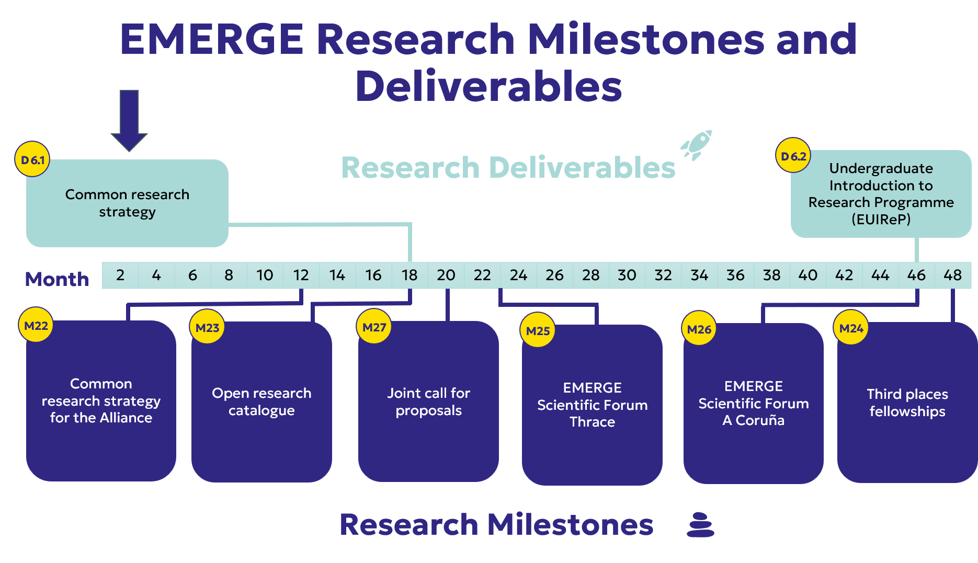
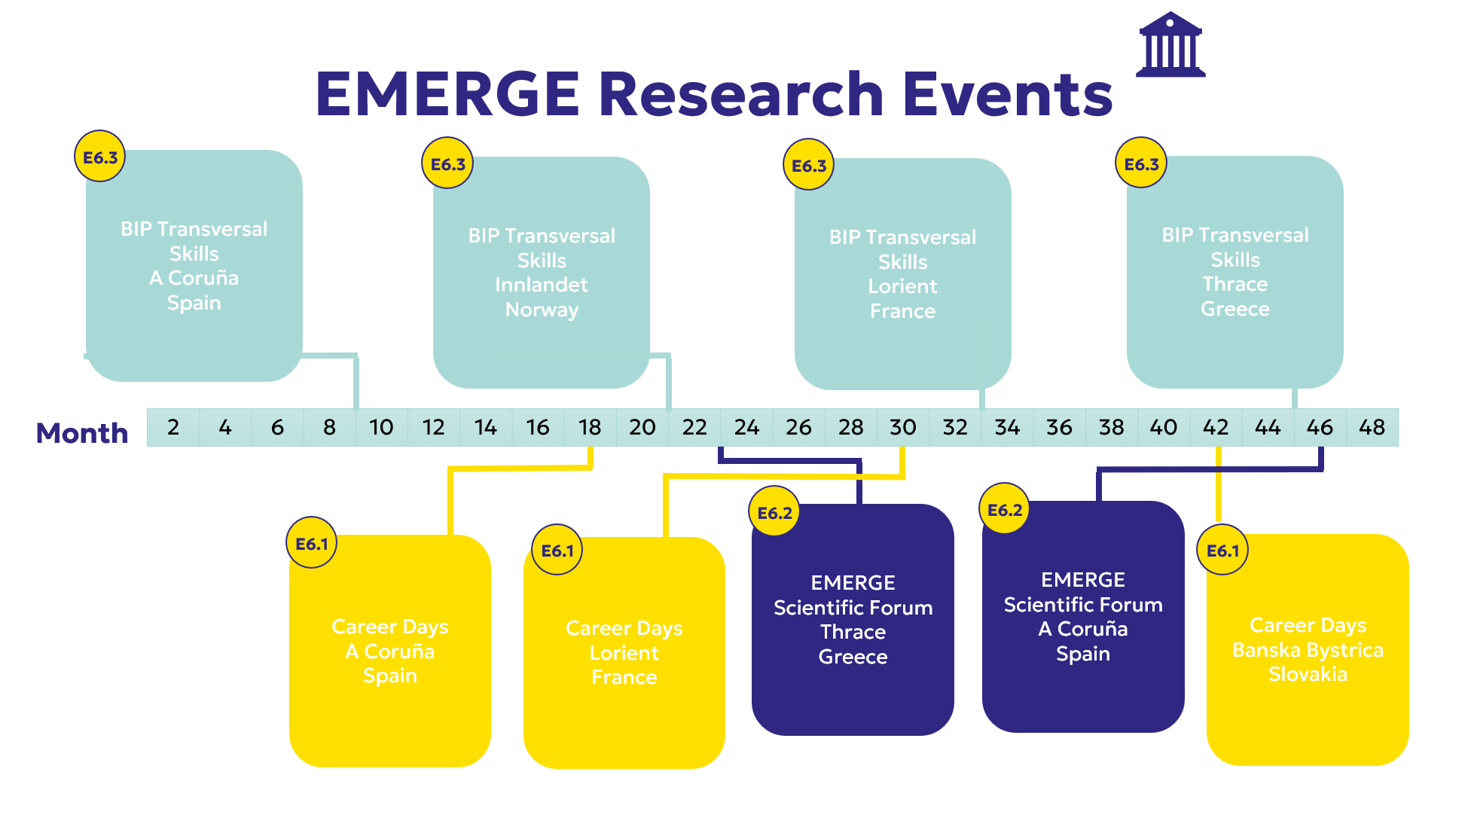

Means and tools
The Alliance research community will be provided with:
Comprehensive communication of current research resources, strategy goals and needs for complementary resources.
As part of the EMERGE Research campus, a comprehensive inventory of current research practices and resources has been compiled, and areas for improvement and opportunities for collaboration have been identified. Once the mapping process is complete, the results will be communicated in a thorough and systematic manner. Information about research resources will be facilitated through a user-friendly interface tool, capable of disseminating and filtering the research-related information, within an open access platform, and linked to professional research international networks. Special attention will be given to including the stakeholder network of the Alliance. This interface facility will be provided in connection with other Alliance communication tools, particularly the tasks assigned to Governance and Project Management, Community Engagement and Services, Educational Programmes and Communication, and Dissemination and Outreach.
A bespoke, self-directed online training programme designed to facilitate and grow engagement in research.
The aim of this training programme is to enable Alliance institutions and their researchers to build cross-disciplinary relationships with peers and mentors and promote collaborative research and learning regarding the ways and means of developing greater stakeholder engagement in research.
Training seminars on community-engaged participatory research tools and methods.
The seminars will highlight a broad range of disciplinary approaches to engaged research, in order to drive and update engaged research training, with best practice exemplars from across the Alliance.
Case studies from across the Alliance, illustrating the ways and means of developing research engagement in various disciplines.
An Alliance archive of best practices will be compiled with simple-to-follow and uniform case study formats, accompanied by short videos. Case studies and pilots will be used to validate research strategies, testing, and refining approaches that support societal engaged participatory research projects. In this sense, several actions will be identified for use as pilot projects. They will provide lessons for application in subsequent research actions.

Further actions
Once the Research Campus has been completed and there is an Alliance-wide and institutional awareness of all current resources and objectives, it will be possible to define shared priorities and goals for research and innovation among member universities, addressing topics in areas of common interest, interdisciplinary research, societal challenges, community engaged projects and industry partnerships. In light of the achievements of the Research Campus during the first year of the EMERGE project, a number of additional research actions—not originally included in the Alliance project—have been identified as strategic and may prove key to Alliance research beyond the Project boundaries. Although desirable, these activities are not compulsory for Alliance members and are subject to inevitable constraints of each participating university.
1. Constitution and consolidation of EMERGE Research Groups.
Building on the EMERGE Thematic Research Clusters, the Alliance will support the establishment and consolidation of EMERGE Research Groups (ERGs). An ERG is a transnational network of researchers or research groups from different partner universities that share common or complementary research interests within the EMERGE Alliance.
To strengthen collaboration and increase their visibility, a catalogue of EMERGE Research Groups will be developed. This catalogue will facilitate connections between researchers, promote the consolidation of existing collaborations, and encourage the creation of sustainable, self-steering research networks across the Alliance.
ERGs will provide a collaborative framework for joint research activities, researcher training, knowledge exchange and community engagement, while also supporting the development of future collaborative initiatives and funding opportunities.
Stakeholder participation within the ERGs is strongly encouraged to ensure that research activities remain relevant and responsive to societal needs. Guidance from the Alliance Community Engagement groups will be sought to support meaningful stakeholder involvement.

The catalogue of EMERGE Research Groups will cover the Alliance's main areas of expertise, with particular emphasis on the four EMERGE Thematic Research Clusters, ensuring a coherent and balanced representation of research capacity across the Alliance.
2. Catalogue for shared research infrastructures.
To facilitate access to research infrastructures across the Alliance and increase the impact and efficiency of research endeavours, a specific mapping of shared research infrastructures, is required. This catalogue will be enhanced with a user-friendly interface providing easy access to research sources in those cases where legal regulations and/or agreements with external contractors, service-providers, as well as the partners’ financial requirements, allow for the sharing of certain research infrastructures. The recommendations in this sense made by Communities of Practice of European Alliances will be taken into account. The EMERGE proposal for a shared system of library loans will be used as a pilot for this task.
3. Eventual strengthening of research human resources interactions among university partners.
Just as physical infrastructures are known and shared, research human resources should also be listed and shared among partners. This should be considered in connection with fellowships activities that promote the mutual knowledge of material resources and human teams. Subject to national legislation, legal agreements with external contractors, and the partners’ financial resources, this action will be implemented through the following measures:
- Search for a common human capital development procedure, to establish shared standards for working conditions and career development to attract and retain top research talent. Closely related to the training and community activities of the Research Campus, this would provide opportunities to participants from all the institutions across various fields of research.
- Eventual opening up of ‘home’ research calls of each of the 9 universities to all Alliance members.
- In the longer term, and subject to legal, institutional and financial feasibility, the Alliance may explore the possibility of recognising researchers from partner institutions as affiliated staff for specific purposes (e.g. access to infrastructures or participation in collaborative research activities). This would facilitate deeper integration and resource sharing across the Alliance.
This action will obviously be subject to approval from the governing boards of the 9 EMERGE partner universities. Being submitted for consideration, its aim will be to be implemented partially at least.
4. Additional quest for funding from public/private institutions beyond the EMERGE Project requirements.
Several of the activities have already focused on training researchers to enhance knowledge of the European Commission's Horizon Europe programme guidelines and its funding opportunities, enabling the Alliance to identify the best funding opportunities for Alliance research. One of the Alliance’s strategic goals is to drive training in these transversal skills in order to enhance the capacity to submit strategic research proposals at national, regional and, in particular, European level. These specially targeted schemes include MSCA PF, MSCA DN, MSCA SE, Excellence Hubs, and calls within the WIDERA ecosystem.
Several of these are required under the Alliance project, particularly those included in the Doctoral Networks. However, the Alliance also seeks to go beyond the minimum requirements. Applications have already been prepared, submitted and listed in EMERGE internal documentation, and further proposals will follow that adjust to the capacities and scope of the Alliance.
This research collaboration should not be only carried out with national and regional governments and local authorities, but also with community-engaged public and private institutions interested in this win-win cooperation. Additional funding possibilities will be sought that make use of the stakeholder network developed both by the Community Engagement and Research groups to strengthen collaboration with regional community-based ecosystems and industries to drive innovation and address societal challenges. This would result in additional funding for the Alliance and valuable knowledge transfer for stakeholders.
5. Calls for short research stays for EMERGE PhDs students.
As an additional task within the Alliance benchmark, a funded proposal has been launched, enabling PhD students to undertake short research stays of between five and fifteen days at other EMERGE institutions or third places. These opportunities will enable early-stage researchers from any EMERGE university to leverage resources, engage in international collaborations with researchers within the Alliance, and participate in research activities in diverse locations, potentially involving new communities in participatory research formats. This action will serve as a pilot scheme that could be replicated by other EMERGE universities or inspire further research initiatives.
6. EMERGE Research Community (EMERGE RechComm).
This initiative is aimed at enhancing research collaboration focused especially on early-stage researchers but that is also open to the Alliance research community as a whole. It will include community building activities, various research initiatives, social media linkages and training activities such as workshops and summer schools, etc). The activities would combine face-to-face events with digital broadcasting and interactions. On-site participation would preferably take place at the EMERGE hubs to foster the visibility of the EMERGE activities. The EMERGE Research Community could also host the EMERGE Undergraduate Introduction to Research Programme.
7. Open Science Practices and Citizen and Society Engagement.
In line with current open science principles and practices to enhance collaboration, transparency, and societal impact, Alliance members should consider adopting the DORA principles in their institutions. The Declaration on Research Assessment (DORA) is a global movement to advance practical and robust approaches to research assessment across all scholarly disciplines. DORA calls attention to new tools and processes in research assessment and the responsible use of metrics that align with core academic values and promote consistency and transparency in decision-making. DORA aims to build a more diverse science community, with an expanded view of what scholarship is and what counts, and advocates for societal engagement with citizens and civil society to ensure that research addresses societal needs and priorities.
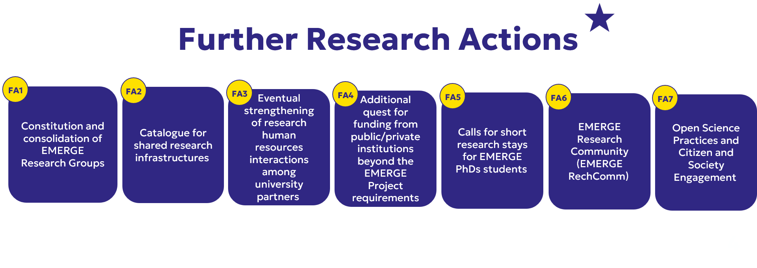

International Science Council (2026). Science Missions for Sustainability, https://council.science/our-work/science-missions/

